Understanding AIAI Customers Through Data-Driven Approaches
  - Subtitle: Insights from Exploratory Data Analysis (Group 68)
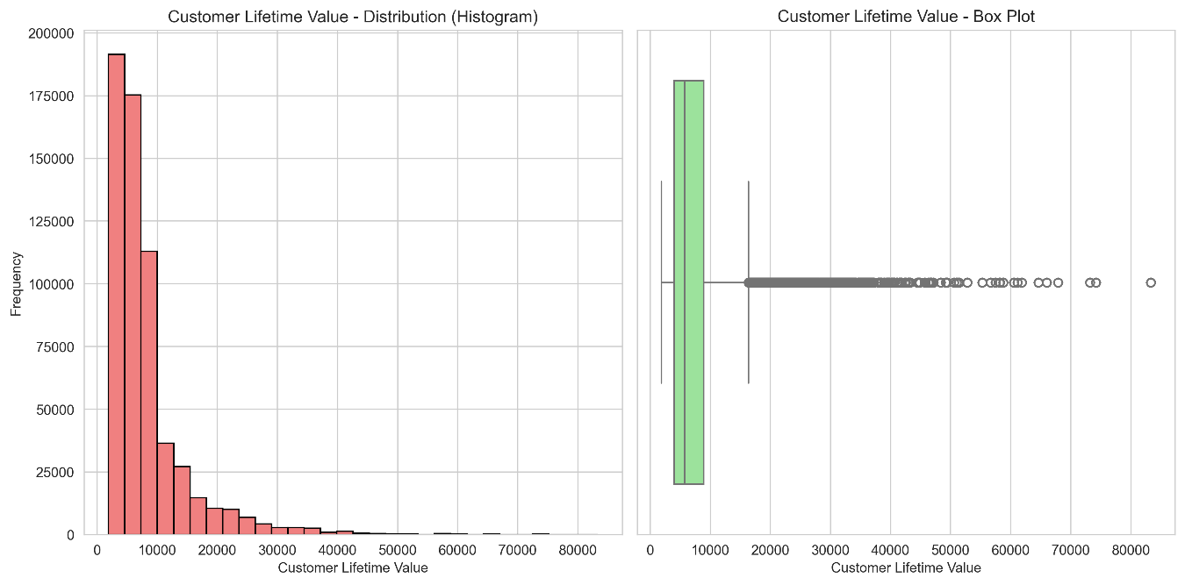

Most consumers fly rarely and earn little points, but a small group of high-income frequent fliers accounts for a disproportionate share of overall revenue.

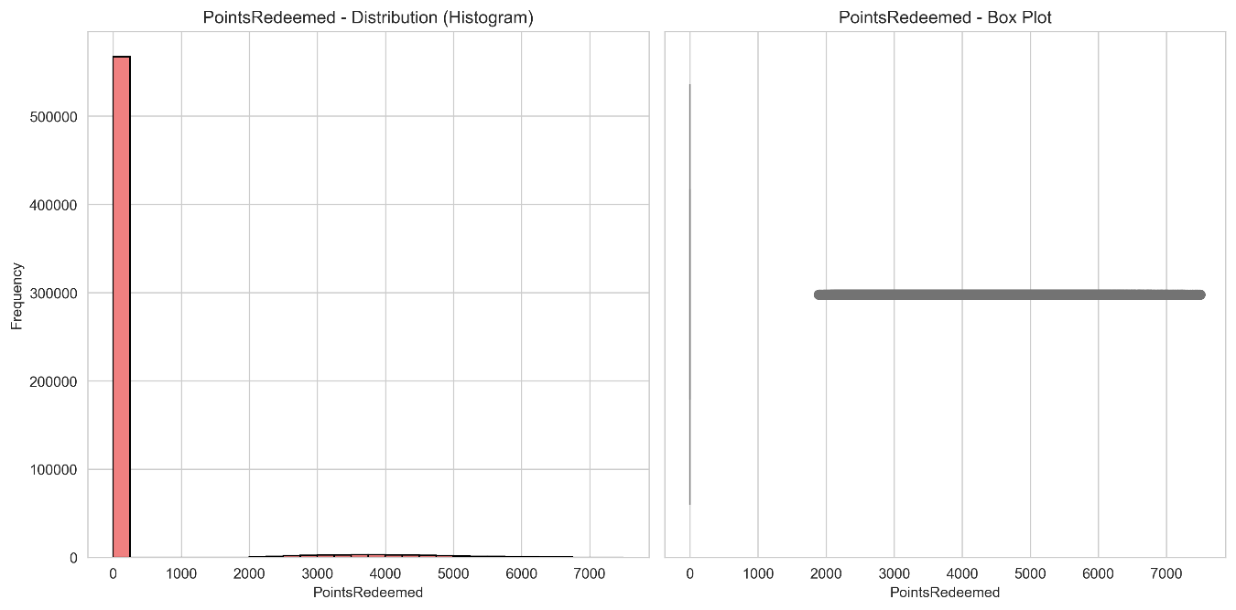

Few consumers utilize their loyalty points; the majority save them permanently, while an extremely select few trades them often for upgrades and airfare.

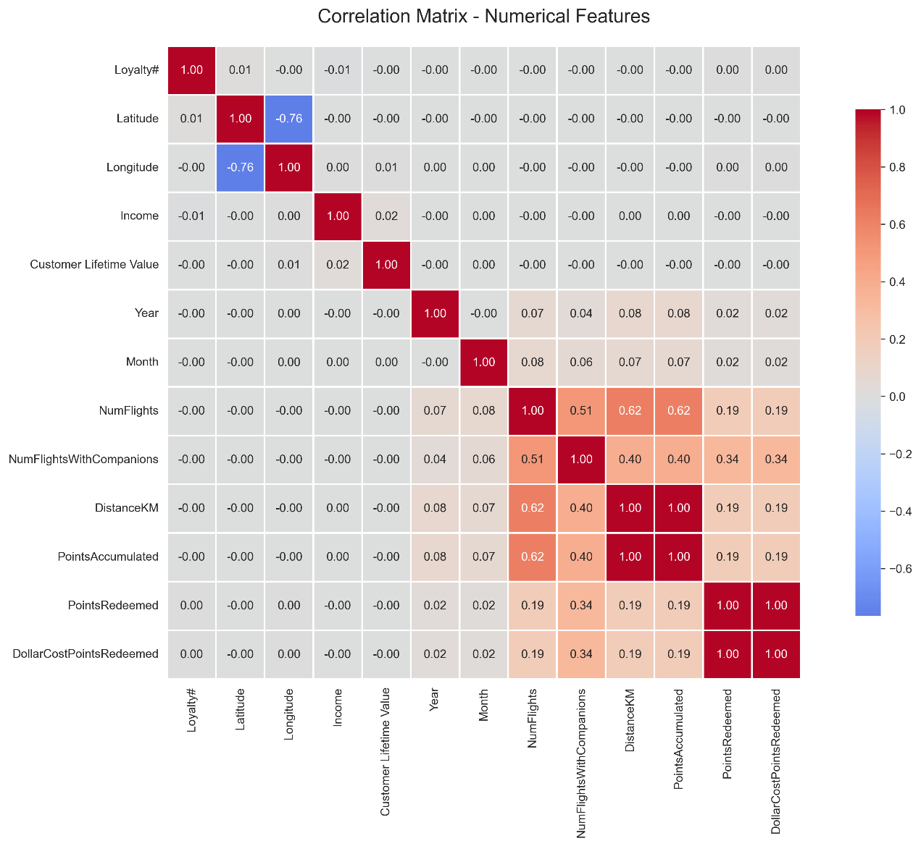

A high positive connection between DistanceKM and PointsAccumulated suggests that consumers who travel greater distances tend to earn much more loyalty points, reaffirming distance as a main driver of value production within AIAI's program.

By determining who produces value and how engagement fluctuates, AIAI can develop a better, segmentation-driven strategy to customer loyalty.

